PPOD Experiments Using a Textured Plate
by Jeremy Nudell
ME 399
June 7, 2010

1. Previous Experiments

1.1. Introduction

As mass produced electronic microparts become more common, creating a reliable method to transport them becomes more important. When the size of the parts approaches the micro scale, the inertial force is overtaken by the adhesion force as the critical component of the parts’ dynamics. Typical parts feeding devices use vibratory driving on a smooth surface. By instead using a textured surface with a saw tooth cross-section, unidirectional parts feeding can occur with symmetric driving vibration. The magnitude of the adhesion force can also be minimized by reducing the contact area between the part and the plate surface.

The Hirai group of Japan recently created an experimental setup, which vibrated textured silicon plates along one axis. The plates had a saw tooth cross-section, as shown in Figure 1.1.1. Electronic microparts were placed on the plates during vibration and the behavior of the parts was analyzed.

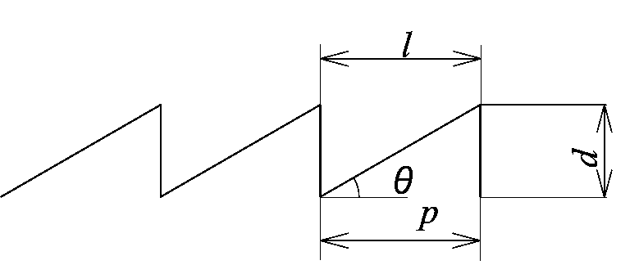
Figure 1: Cross section of textured silicon plate

Although Hirai’s paper comprehensively explains the dynamics of a micropart on a saw tooth surface vibrating with one degree of freedom, his group was limited by only being able to move along one axis. The Parts-feeding Programmable Oscillatory Device (PPOD), developed in the LIMS lab at Northwestern University, allows for vibration in all six degrees of freedom. With access to this device, Hirai’s experiments can be replicated, and then generalized to more complicated plate vibrations.

1.2. Summary of Hirai’s setup

Figure 2 shows a photo of the microparts feeding system, and Figure 3 schematizes the driving system. Two piezoelectric bimorph elements were used as actuators. One side of each actuator was fixed, while the other side was hinged to a feeder table. The bending motion of the two actuators was transferred to the linear motion of the feeder table. The feeder table was fixed on a linear guide for the uniaxial motion within the horizontal plane. The actuators were driven by a function generator and an amplifier capable of delivering a peak-to-peak output voltage of up to 300 V. The silicon wafers were attached onto the surface of the feeder table.¹

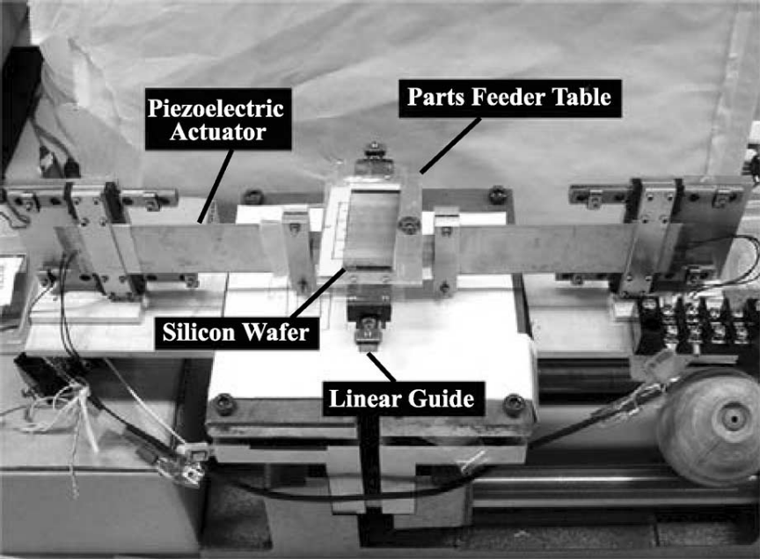
Figure 2: Picture of Harai’s experimental setup

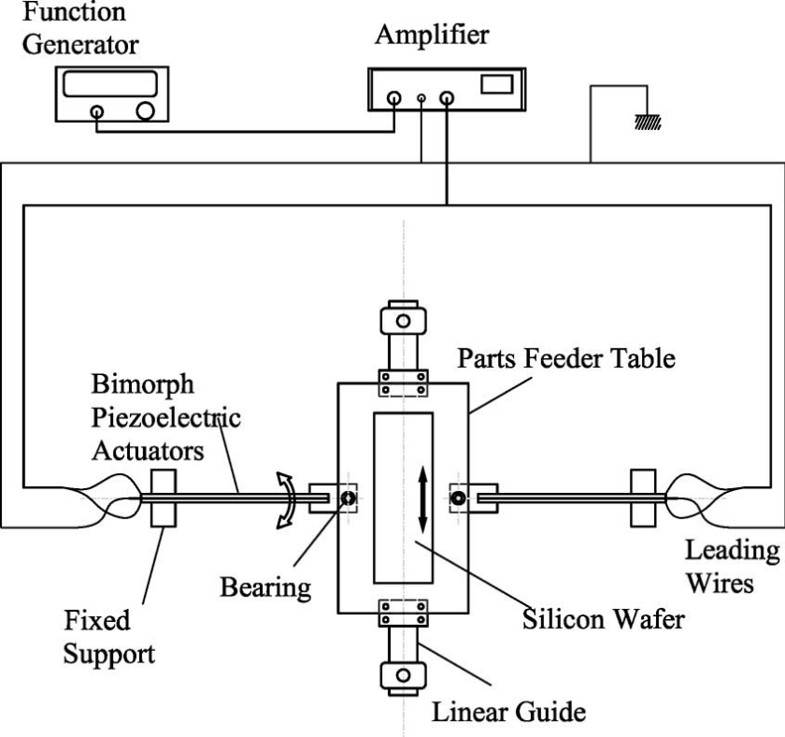
Figure 3: Schematic of microparts feeder

1.3. Summary of Hirai’s results

First, a 1005 type capacitor, a 2012 type capacitor, and a small silicon wafer chip were placed on a 30° textured plate. The plate was oscillated at 15Hz with a 120V peak-to-peak square wave. The plate was rotated 180°, and oscillated again. The capacitors moved in one direction with respect to the plate, while the silicon chip followed the back and forth motion of the plate (see Figure 4). This suggests that the capacitors move in one direction because of the convexities on their electrodes.¹

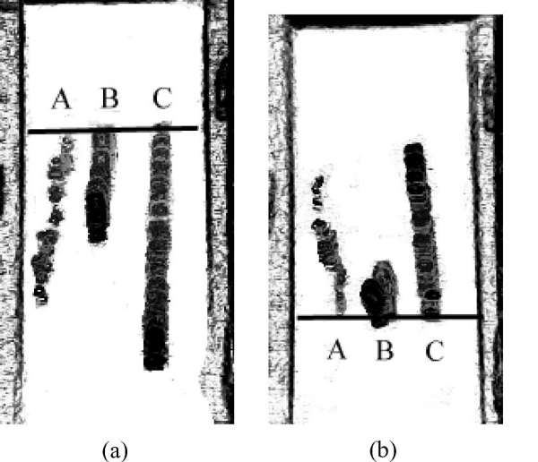
Figure 4: Directionality of feeding. A- 1005 type capacitor, B- silicon chip, C- 2012 type capacitor.

Experiments were first performed on the 2012 type capacitor using a 30° surface and a 120V peak-to-peak square wave. Figures 4, 5, and 6 show the results for driving frequencies of 10Hz, 15Hz, and 30Hz, respectively.

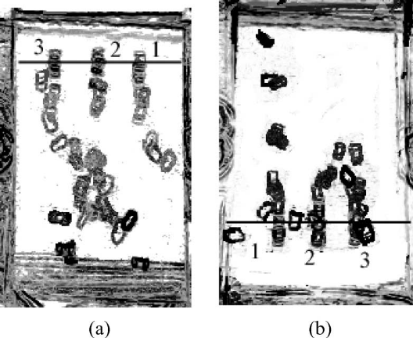
Figure 5: 2012 type capacitor, 10Hz, 1 second elapsed

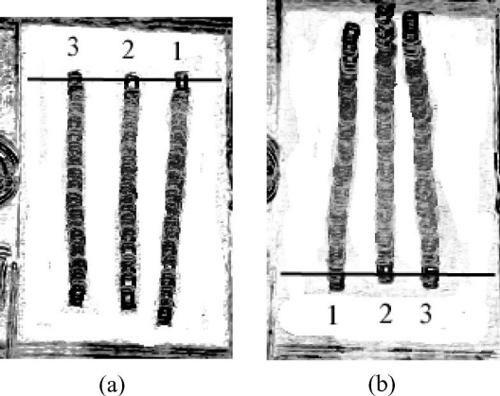
Figure 6: 2012 type capacitor, 15Hz, 4 seconds elapsed

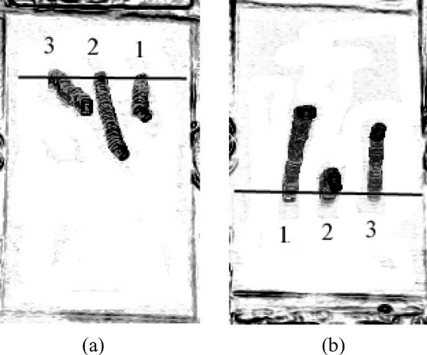
Figure 7: 2012 type capacitor, 30Hz, 8 seconds elapsed

Figure 7 shows the results of a 2012 type capacitor on a 60° surface, oscillated at 15Hz. The parts moved in opposite directions, thus unidirectional feeding was not achieved for the 60° surface.

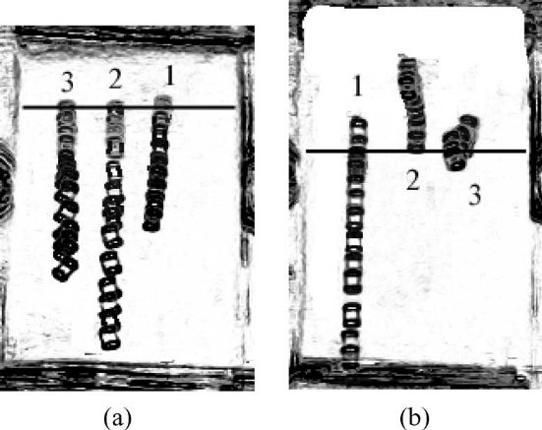
Figure 8: 2012 type capacitor, 15Hz, 2 seconds elapsed

Table 1 shows the average velocities of the microparts on different types of saw tooth surfaces and the time it took them to move across the 30mm long surface. The parts were oscillated at 15Hz. The values were averaged over thirty trials.

Table 1- Experimental Results
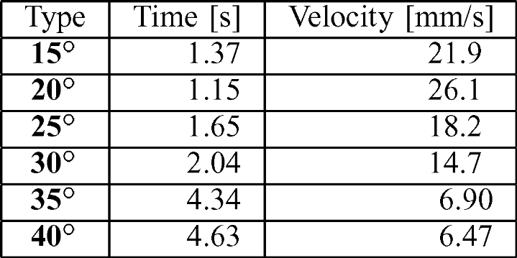

1.4. Summary of Hirai’s Analysis

Hirai concluded that the unidirectional feeding is achieved due to the convexities on the surface of the micro parts (see Figure 9)

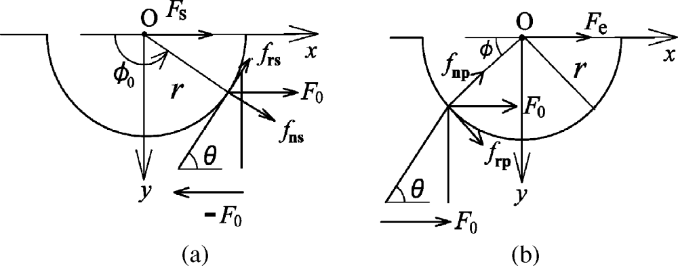
Figure 9: Schematic of static forces

When the plate is moving to the left, the driving force Fs is due to a slope contact. When the plate is moving to the right, the driving force Fe is due to a point contact. The proposed equations for the two forces are given below:

Fs = F₀(1 − μ_{s} cos θ sin θ)
Fe = F₀ cos φ(cos φ − μ_{e} sin φ)

On average, Fe>Fs, which causes the parts to move to the right, even though the vibration is symmetric.

2. Experimental Setup, Procedure, and Data Processing

Note- specific instructions on how to use the MATLAB programs can be found in the .m files. Comments for trackmovemasterXXXX functions can be found in the trackmovemasterside function.

2.1. Preparation

Before any data was taken, the textured plate was cleaned to remove particulates and oils. The plate was placed in a beaker along with alcohol and ultrasonically cleaned for three minutes. The alcohol was then drained and replaced with acetone, and the beaker was placed in the ultrasonic cleaner for another three minutes. This process was repeated every few weeks throughout the experiment.

In order to affix the textured plate to the surface of the PPOD, sticky wax was placed on the four corners of the plate and it was pressed onto the PPOD. Black electrical tape was laid around the outside of the textured plate to maintain contrast between the lightly colored microparts and its surroundings.

2.2. Camera System

A ====== video camera with an external trigger was used to capture data. The camera was mounted on a tripod equipped with a horizontal attachment, allowing the camera to be positioned with the lens facing down towards the PPOD plate. The code of the PPOD controller was edited so it sent a logic low pulse to the camera once every plate cycle. Thus, the camera was able to record only the motion of the part, while the plate appeared to remain stationary.

A MATLAB script called GetFrames.m was written to collect video data, using functions from the Image Acquisition Toolbox. Every time this script was run, it took several minutes of initialization time before the program was able to start logging data. Consequently, it was very inconvenient to restart this script with every video. To solve this problem, a pushbutton switch was placed in between the camera’s trigger signal input, and the PPOD controller’s trigger output. The pushbutton switch was high when unpushed, and allowed the low pulse to pass through when pushed. With this setup, the camera recorded frames only when the button was pushed. The GetFrames program was modified to separate the frames into individual videos by inspecting the corresponding timestamps.

2.3. Part Delivery

A simple paper chute system was created in order to drop the parts on the plate at approximately the same velocity with each trial.

2.4. Lighting

The lighting had to be carefully adjusted before taking data in order to maximize the contrast between the lightly colored micro part and its surroundings. After trying several different types of lights, a single incandescent bulb directly above the textured plate, level with the video camera, seemed to work best. Keeping ambient light as low as possible also seemed to improve contrast.

2.5. Coordinate Transformation

After the camera recorded video, and a function was implemented to track the movement of the part (discussed in section 2.7), another function had to be created to convert the location of the part from the camera reference frame in pixels, to the world reference frame in millimeters. See Figure 11.

To accomplish this, a strip of paper the same width as the textured plate but slightly longer was cut. The strip was patterned with a series of dots at known spacing. Before each data taking session, a picture was taken of the dot strip after it was lined up on three sides with the sides of the textured plate.

A MATLAB function was created, called perspective.m, which takes as an input the known location of the dots on the strip, and the location of the centroids of the dots, in the camera’s coordinate system. The output of the program is the coordinate transformation matrix. Another function, calim works in conjunction with the perspective program. It calculates the position of the calibration dots in image coordinates, and it also contains information about the dot spacing.

Equation 1
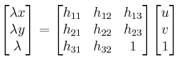

The above equation gives the world coordinates x and y in homogeneous form as function of the transformation matrix multiplied by the image coordinates u and v. Rearranging the equation to put the transformation coefficients in a single vector, yields:
Equation 2
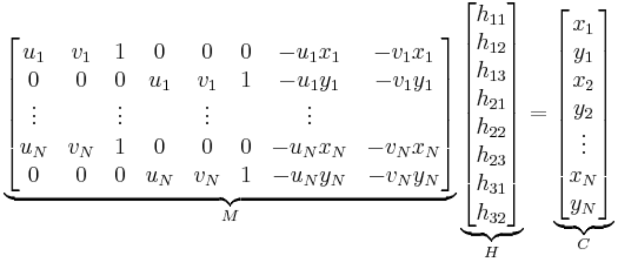

Computing M\C in MATLAB conveniently calculates the transformation coefficient vector, H. The perspective.m program then rearranges the coefficient vector to create the transformation matrix shown in equation 2.

The perspective transformation works well for 2D coordinate resizing, rotation, skewing, and axis flipping. However, this method does not account for distortion of the image. In order to check whether the distortion effect was noticeable, a picture was taken of the calibration strip and the perspective.m function was used to determine the transformation matrix. Then, the known coordinates of the calibration dots were sent through the inverse of the transformation matrix, and those coordinates were plotted on top of the calibration image. See Figure 10.

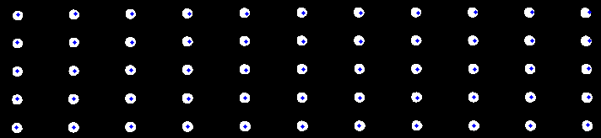
Figure 10

Although some distortion is noticeable near the outside dots, it was concluded that the zero-distortion assumption was reasonable.

2.6. Axes Calibration

The PPOD has no markings to indicate its x and y shaking axes. Therefore, a calibration had to be implemented to make sure that the axes of the textured plate were lined up with the shaking axes of the PPOD. See Figure 11.

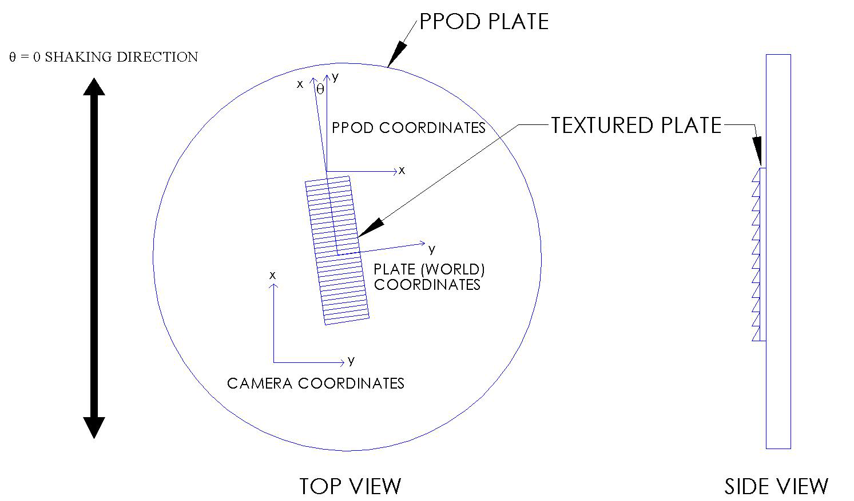
Figure 11

First, a small dot was drawn on the surface of the PPOD near the plate, and under the calibration strip. Then, the calibration strip was lined up with the textured plate, and a picture was taken. By telling the PPOD to shake purely along one axis, tracking the dot on the PPOD plate, and converting those coordinates to the textured plate’s coordinate system, it could determined whether or not the two coordinate systems were aligned. However, the camera could not take pictures at a frequency fast enough to capture the un-aliased motion of the dot. Therefore, the software controlling the camera trigger was edited to take a picture at intervals slightly longer than one plate cycle. The magnitude of vibration in the x and y directions (in the textured plate’s coordinate system) could then be determined by finding the amplitudes of the sine waves of the aliased dot motion using a function called calvid.m. These curves are shown in Figures 12 and 13. An image of the textured plate and calibration dot is shown in Figure 14.

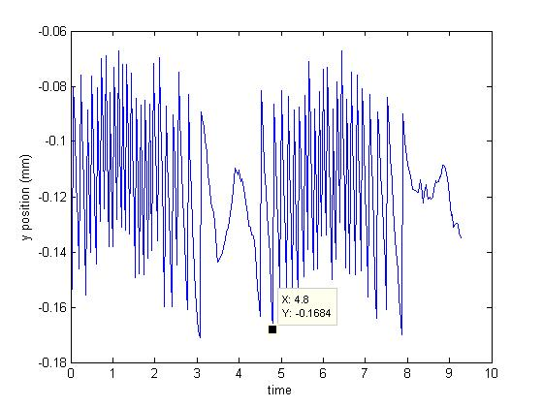
Figure 12: Y motion of dot in calibration video
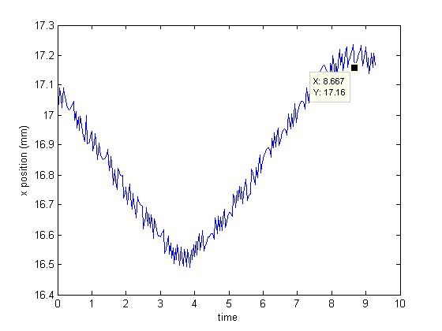
Figure 13: Y motion of dot in calibration video

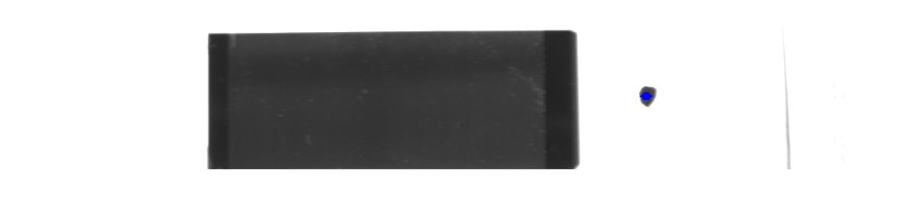
Figure 14: Image of textured plate and calibration dot

Taking the inverse tangent of ratio between the two curve amplitudes yields the angle between the textured plate axes and the shaking axes of the PPOD. This angle turned out to be around 3º. This value was considered negligible. The textured plate position relative to the PPOD was marked using tape (for future reference), and experiments were continued.

2.7. Tracking Program

The series of Matlab functions, trackmovemasterXXXX.m, take as an input a structure variable containing all trials of videos at one operating condition. This variable is created by the output of the GetFrames function. The structure also contains the calibration image, information about the environmental conditions during data taking, and the type of plate motion. The program goes through the following steps to analyze the motion of the micro part:

- Displays the calibration image. The user drags a rectangle around the portion of the image that contains the calibration dots.

- Determines the coordinate transformation matrix using the perspective and calim functions

- Displays last frame in video. The user clicks the location of the part on the image.

- Differences the first frame of the grayscale video with all the subsequent frames in the video. Pixels that are unchanged throughout the video show up darker, and pixels that change show up lighter.

- Thresholds to convert the differenced video from grayscale to black and white

- Crops the last frame in the video to a small square, centered around the user’s click from step (3)

- Uses MATLAB’s Image Processing Toolbox to delete erroneous white pixels, fill in black pixels within the boundary of the micro part, and calculate the centroids of the part. Because the two electrodes of the part show up brighter than the middle, in some frames the middle of the part will still show up black. In this case, the program calculates the centroid of the entire part as the average location of the centroids of the two electrodes.

- Calculates the orientation of the part using a custom function named secondmoment.m. The function works by determining the second moment of area of the part. A part orientation of zero degrees corresponds to when the long axis of the part is aligned with the long axis of the textured plate.

- Converts the location of the centroid from the cropped box, to the location in the full image.

- Trims the data so it only contains the location of the part when it is in a specified range on the plate.

- Converts the centroid location from the camera frame of reference in pixels, to the textured plate (world) frame of reference in millimeters, using the transformation matrix calculated in step (2).

- Cycles through the frames of each video in the input structure, calculating the aforementioned values. The center of the cropped image is taken as the location of the centroid in the previous frame.

- Outputs a structure containing the following data for each video:
  - Centroid location vector (containing x and y position values)
  - Time vector
  - Orientation vector
  - Orientation mean
  - X velocity vector
  - X velocity mean
  - X velocity standard deviation
  - Y velocity vector
  - Y velocity mean
  - Y velocity standard deviation

There are four different variation of this function. Trackmovemasterforward is used when the part is moving with the plate bias, trackmovemasterbackward is used when the part is moving against the plate bias, trackmovemasterside is used when an x component is introduced into the PPOD plate vibration, and trackmovemasterstop is used when the part does not have a significant velocity in any direction.

As a test of functionality, the center location of the part and orientation at each frame in the video can be plotted on the same image. This is shown in Figure 15.

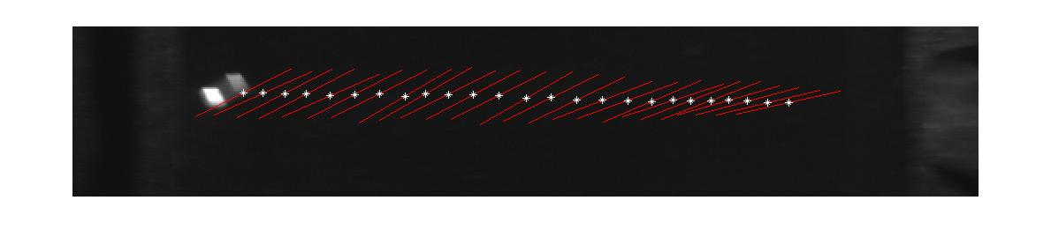
Figure 15: Centroid and orientation of the part at each frame overlaid on a single image

When the output structure is obtained, it can then be sent to another function, called plotcentroids.m, which creates plots of the following variables:
- X position vs. Time
- X velocity vs. Time
- X velocity vs. X position
- Y position vs. Time
- Y velocity vs. Time
- Y velocity vs. Y Position
- Orientation vs. Time
- Orientation vs. X position

It also averages the following quantities for all videos in the structure (under a single operating condition), displaying an overall mean for the following values:
- X velocity
- X velocity standard deviation
- Y velocity
- Y velocity standard deviation
- Orientation

2.8. Accessing data

Data from all experimental sessions was stored on the computer next to the one that controls the PPOD. Raw video is contained in structures (.mat files), mentioned above. They are named dataXXXX, with a suffix containing information about the operating condition. For example, data1420 contains the videos of the part with the PPOD controller set at 14m/s² at 20Hz. A custom function called play.m can be used to play the videos. To call this function, one would enter into the command line:

>> play(data1420.frames(vidnum).frames)

where vidnum is the desired video number.

The structures containing the analyzed data (the output of the trackmovemaster function), are also saved on the computer. They are named centroidsXXXX where the suffix is the same as for the dataXXXX structures.

3. Results of Experiments

3.1. Replication of Hirai’s 1DOF Experiments

Note 1: Due to the limited availability of parts, all experiments were performed using the 30 degree, .125mm pitch saw tooth surface.

Note 2: Driving voltage was given in Hirai’s Article, not maximum acceleration, and no correlation was given between the two. Therefore, values for maximum acceleration were chosen which seemed to produce reliable unidirectional feeding without overdriving the PPOD actuators.

Note 3: Most velocities in this section are shown as negative. As a convention, negative velocities correspond to part motions that are with the plate bias.

First, a small chip from one of the textured silicon plates was oriented so the smooth side faced down. Then, it was placed on top of the larger textured plate and oscillated at 15Hz, with an acceleration amplitude of 10 m/s². The silicon chip oscillated back and forth with the plate, suggesting that the directionality of feeding is due to the convexities on the part’s surface.

Next, 15 videos were taken at each of the operating conditions listed in Table 2. Vibratory motion was purely in the y direction, as shown in Figure 11.

Initially, the data was only slightly trimmed, so that most of the part’s motion was captured for analysis. However, for every operating condition tested, the graph of x velocity vs. x position looked similar to the plot shown in Figure 16.

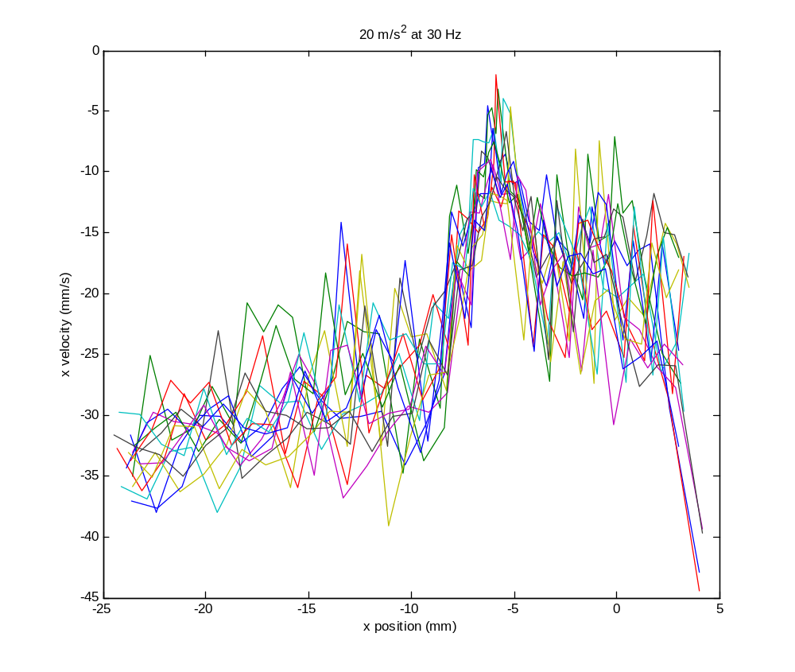
Figure 16: Plot of x velocity vs. x position, showing non-uniformity in plate

The part velocity seemed to slow down or stop at exactly -6mm for every trial. It was concluded that there existed a non-uniformity on the plate at that location. Therefore, the rest of the analysis for 1 DOF motion was continued, trimming the data between the plate locations -22mm and -10mm, where the part velocity seemed relatively constant. The following representative graphs are from the analysis for operating condition (10). All trials are plotted on the same graph.

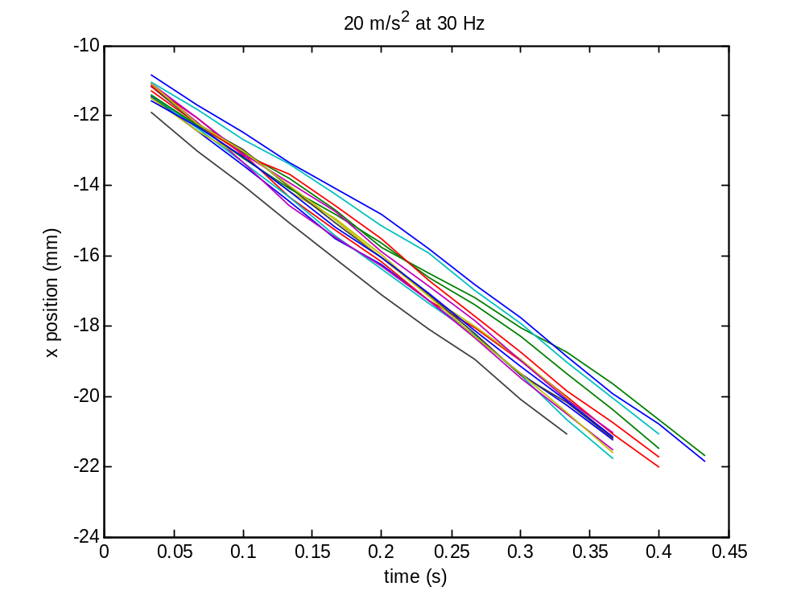
Figure 17: X position vs. time

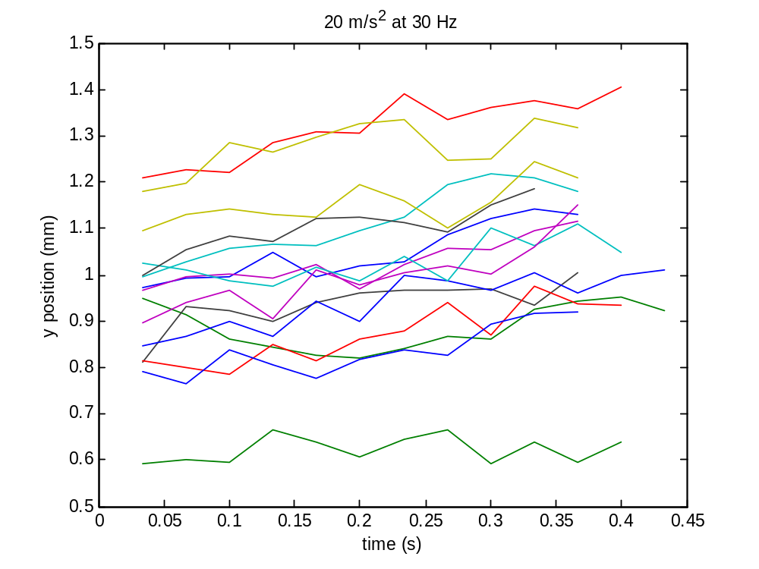
Figure 18: Y position vs. time

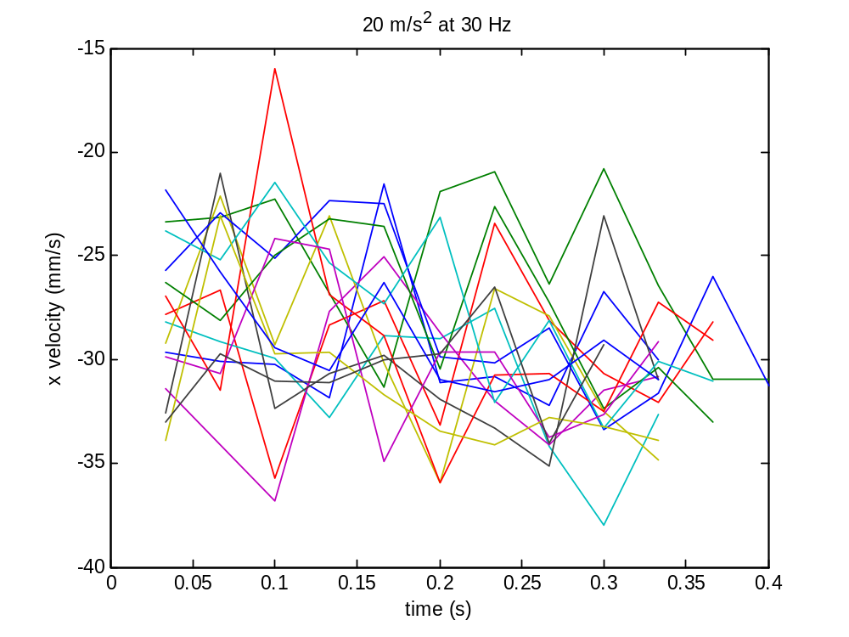
Figure 19: X velocity vs. time

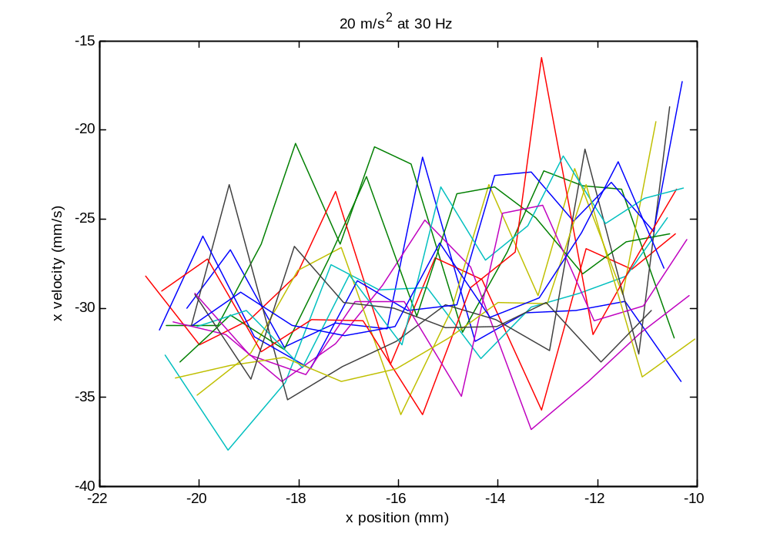
Figure 20: X velocity vs. x position

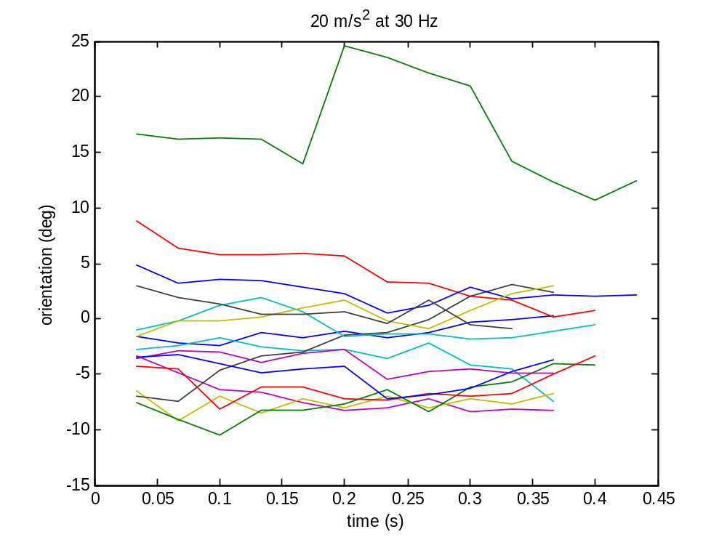
Figure 21: Orientation vs. time

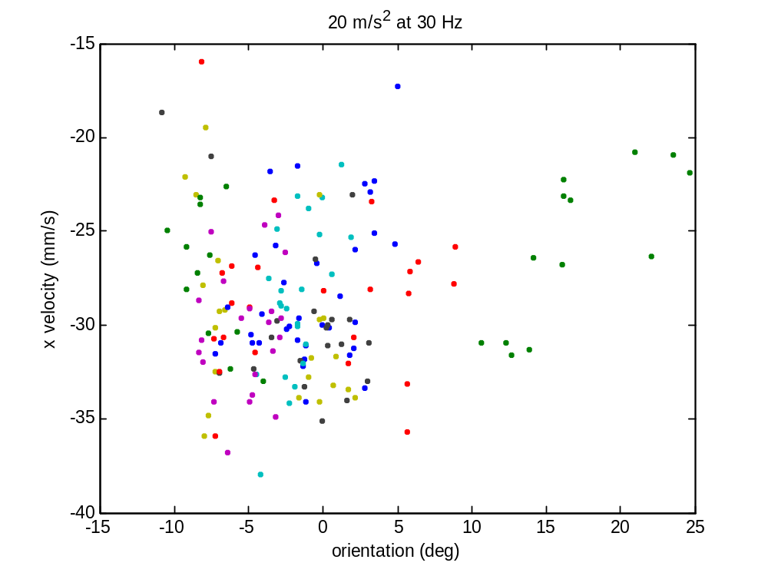
Figure 22: X velocity vs. orientation

The position data appears very smooth, and consistent with the part behavior observed in the videos. After studying the graph in Figure 22, there does not seem to be any correlation between part velocity and orientation. However, the part orientation does seem to converge with time to an angle slightly offset from zero. This phenomenon is more apparent in the untrimmed data, such as the plot in Figure 23.

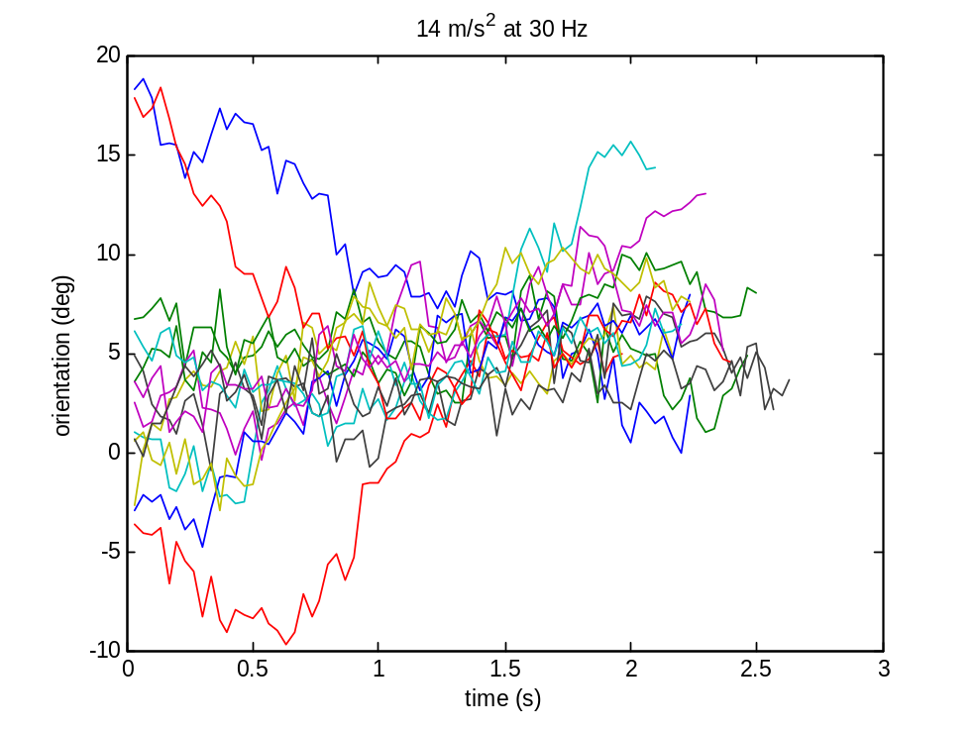
Figure 23: Orientation vs. time

Table 2 shows a summary of mean velocity with standard deviation for all operating conditions.

Table 2
Operating Condition No. | Plate Accel. (m/s²) | Plate Freq. (Hz) | Mean Vel. (mm/s) | Vel. Std.
1 | 14 | 15 | -28.6 | 1.54
2 | 14 | 20 | -24.2 | 2.06
3 | 14 | 25 | -17.1 | 3.52
4 | 14 | 30 | -15.2 | 2.22
5 | 17 | 20 | -34.1 | 1.38
6 | 17 | 25 | -24.2 | 3.28
7 | 17 | 30 | -19.5 | 5.04
8 | 20 | 20 | -43.3 | 1.52
9 | 20 | 25 | -32 | 2.78
10 | 20 | 30 | -28.9 | 3.83
Figure 24 shows one graph of part velocity vs. frequency at a fixed amplitude, and Figure 25 shows one graph of part velocity vs. amplitude at a fixed frequency. The error bars indicate +- 1 standard deviation.

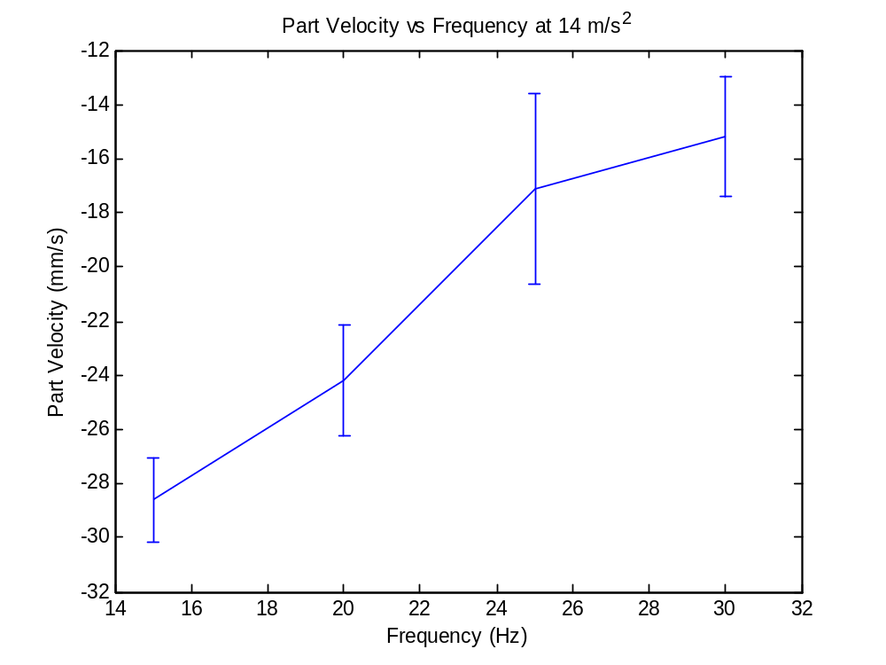
Figure 24: Velocity vs. frequency at fixed amplitude
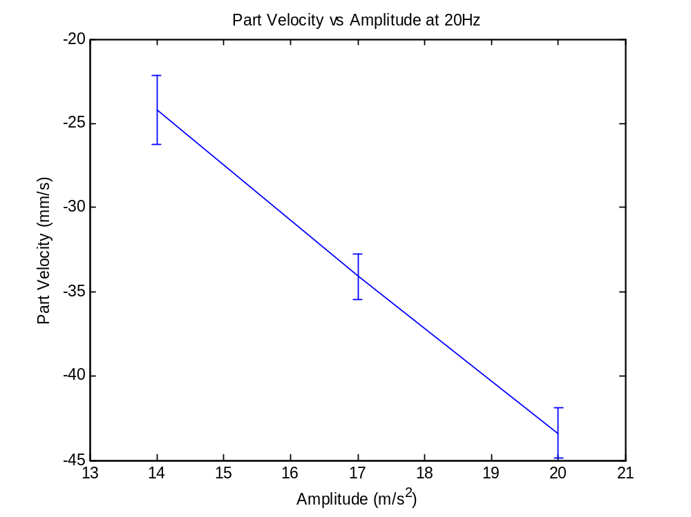
Figure 25: Velocity vs. amplitude at fixed frequency
Part velocity appears to increase linearly with vibration amplitude, and decrease linearly with vibration frequency. The part velocity at 15Hz is around 2 times the part velocity listed in Table 1 for Hirai’s experiment using a 30° saw tooth plate. This is most likely because the amplitudes used in the above experiments were larger than the ones used by Hirai. Nonetheless, the 1 DOF experiments provided sufficient evidence that the experimental procedure and data processing programs function properly.

3.2. Trans Field Experiments

Hirai was only able to study motion of the micro parts when the textured plate was vibrated along a single axis. Using the PPOD as a vibratory device makes studying out of plane motions possible. One motion of interest, in particular, is the one achieved by introducing a small z component (perpendicular to the PPOD plate) to the single axis vibration. In this way, the force of friction experienced by a part placed on the PPOD’s smooth surface can be made smaller when the plate is traveling in one direction and larger when the plate is traveling in the opposite direction. This is because the normal force is dependent upon acceleration in the z direction. The result is a ‘trans field’, which causes a part on the PPOD’s surface to experience non-zero velocity along a line. By adjusting the phase between the in-plane and out-of-plane motions, one can control the direction and magnitude of the part’s velocity.

The trans field is an interesting one to explore when studying textured plates, because they both produce the similar effect of an anisotropic friction force. Thus, it is plausible that the effect of the bias on the textured plate and the effect of the trans field can be combined in different ways to increase or decrease the overall anisotropy of the friction force.

To test this conjecture, the motion of the micro part on the textured plate was tracked with a plate motion of 14m/s² in the y direction, 5m/s² in the z direction, and a frequency of 20Hz. The phase of the z motion was varied from 0 radians to 2π radians in increments of 1/8 π. 8 videos were taken at each phase. The textured plate was then flipped over, and the experiment was repeated with the micro parts traveling along the smooth side of the textured plate as a reference.

The effect of the non-uniformity on the plate’s surface, mentioned in the previous section, seemed to be quite small after a z component was introduced to the plate’s vibration. Therefore, the following analysis includes part motion along most of the textured plate, from about 0mm to -28mm. The graphs below correspond to a phase offset of 7/8 π, one in which the textured plate bias and the trans field were along the same direction.
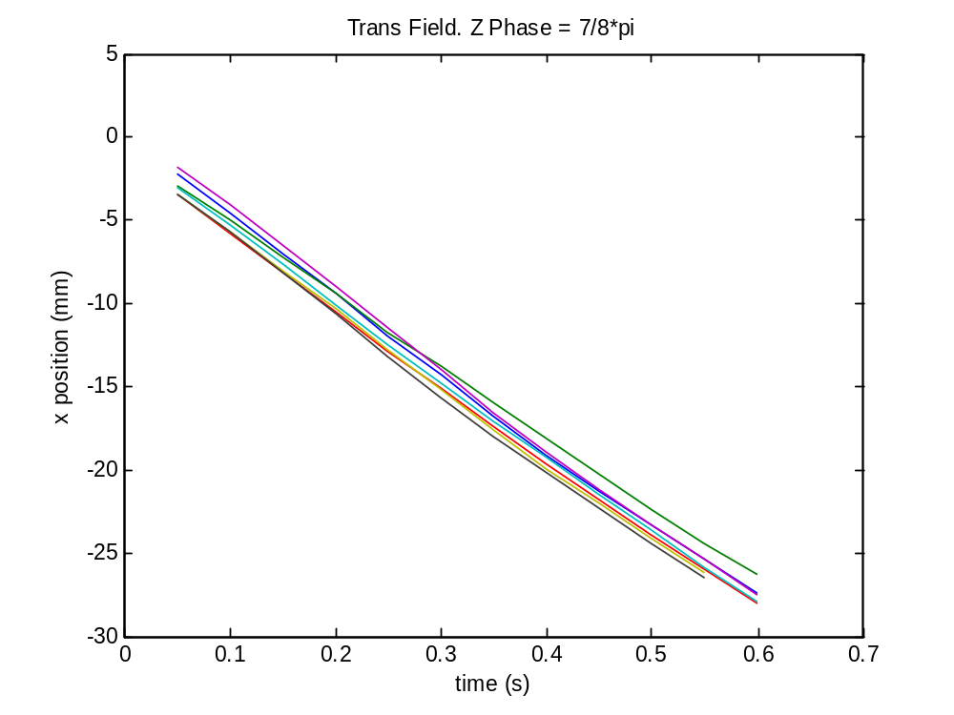
Figure 26: X position vs. time

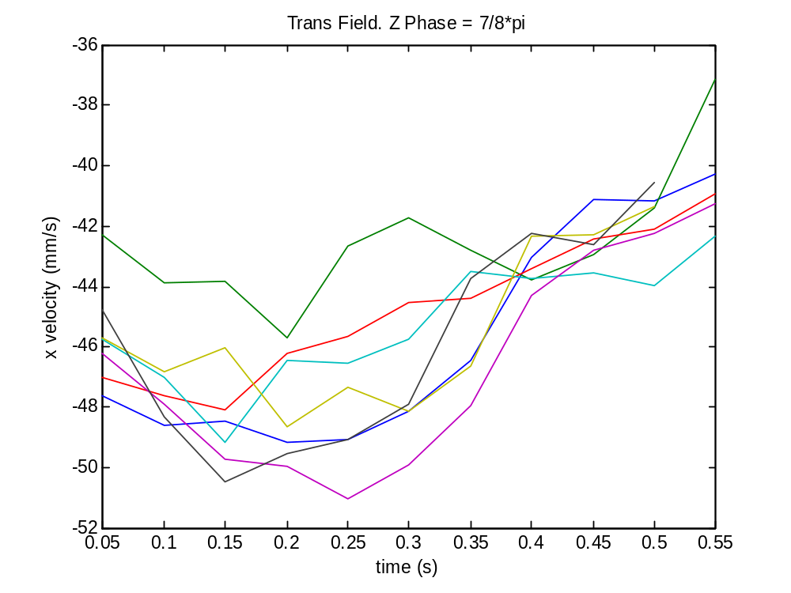
Figure 27: Y position vs. time

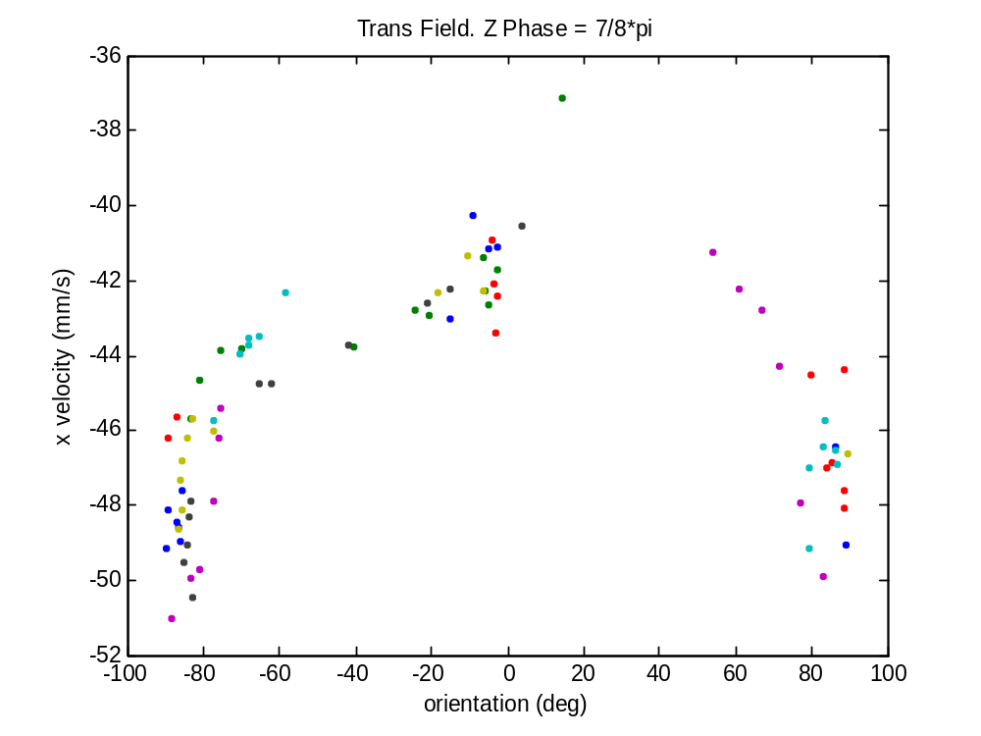
Figure 28: X velocity vs. orientation

Unlike the velocity vs. orientation graphs from the 1 DOF motion that showed no correlation, the points on the graph in Figure 28 seem to produce an arc shape. This graph looked similar at several other phases. This might suggest that part orientations closer to 90 degrees produce greater velocities.

The graphs below correspond to a phase offset of 14/8 π, one in which the textured plate bias and the trans field were along the different directions

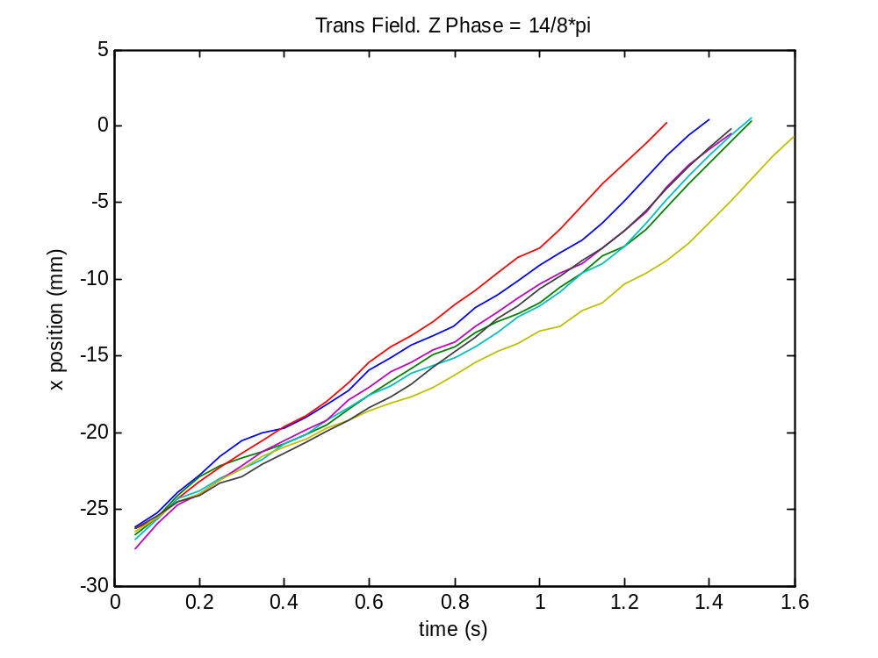
Figure 29: X position vs. time

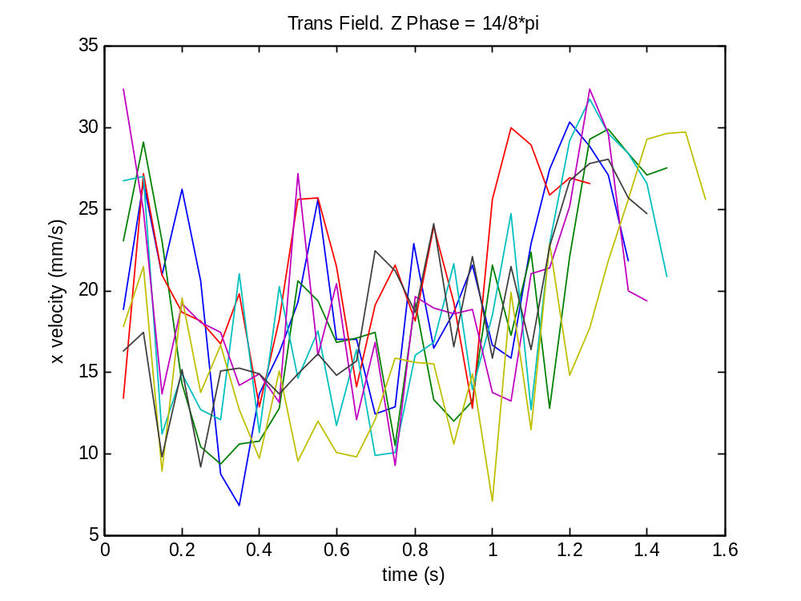
Figure 30: Y position vs. time
.

By using certain phases, it is apparent that the effect of the trans field can overtake the effect of the textured plate bias, causing the part to move with positive velocity. Table 3 summarizes the velocity data for the trans field experiment using both the textured side of the plate, and the non-textured side of the plate.

Table 3
 | Smooth Plate |  | Textured Plate
Phase | Velocity (mm/s) | Std | Velocity (mm/s) | Std
0 | 23.2 | 8.32 | 12.4 | 6.12
1/8*pi | 11.3 | 7.58 | -8 | 4.9
2/8*pi | 1.7 | 10.3 | -9 | 5.3
3/8*pi | -14.6 | 7.17 | -29.4 | 3
4/8*pi | -23.2 | 6.75 | -24.8 | 5.86
5/8*pi | -30.4 | 5.01 | -39.1 | 2.85
6/8*pi | -34.9 | 3.66 | -43.2 | 3.48
7/8*pi | -35.3 | 3.06 | -45.3 | 2.74
8/8*pi | -22.6 | 6.2 | -44.7 | 3.12
9/8*pi | -15.9 | 8.17 | -36.6 | 5.68
10/8*pi | -0.32 | 6.36 | -17.8 | 8.36
11/8*pi | 15.3 | 6.57 | -0.05 | 2.8
12/8*pi | 26.6 | 5.6 | 0.45 | 3.2
13/8*pi | 29.4 | 7.76 | 13.6 | 6.48
14/8*pi | 35.3 | 4.97 | 19.4 | 6.29
15/8*pi | 29.7 | 6.54 | 19.1 | 6.55

Figure 31 shows a graph of the velocities from Table 3 along with error bars. Although data was only taken for one cycle of phase, the graph is shown with two cycles (one cycle repeated) to depict the sinusoidal nature of the velocity data.
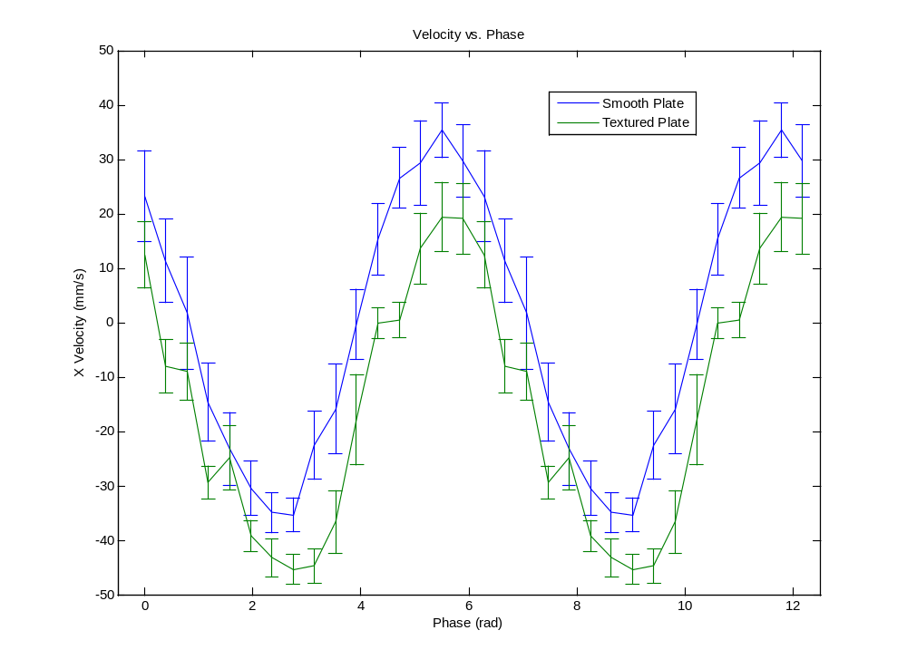
Figure 31: Velocity vs. phase

The mean of the velocity data for the smooth side of the plate was -.30mm/s, while the mean of the velocity data for the textured side of the plate was -14.60mm/s. As expected, the effect of the saw tooth texture seemed to offset the velocity vs. phase curve by a fixed velocity. That offset was calculated to be -14.3mm/s.

3.3. In-plane Experiments with Angular Offset

Finally, the effect of vibrating the PPOD plate along one axis at an angle θ to the axes of the textured plate (see Figure ====) was studied. The acceleration magnitude and frequency of the PPOD plate motion were held constant at 14m/s² and 20Hz, respectively, while θ was varied from 0° to 90° in increments of 11.25°. The required x and y amplitude inputs to the PPOD controller were found by solving the following system of equations for each θ:

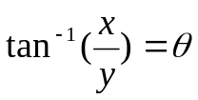
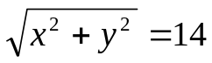

Shown below are representative graphs of the analysis for θ=22.5°. The data was trimmed according to the part position along the y axis of the plate, rather than the x axis, as was done for the previous experiments.

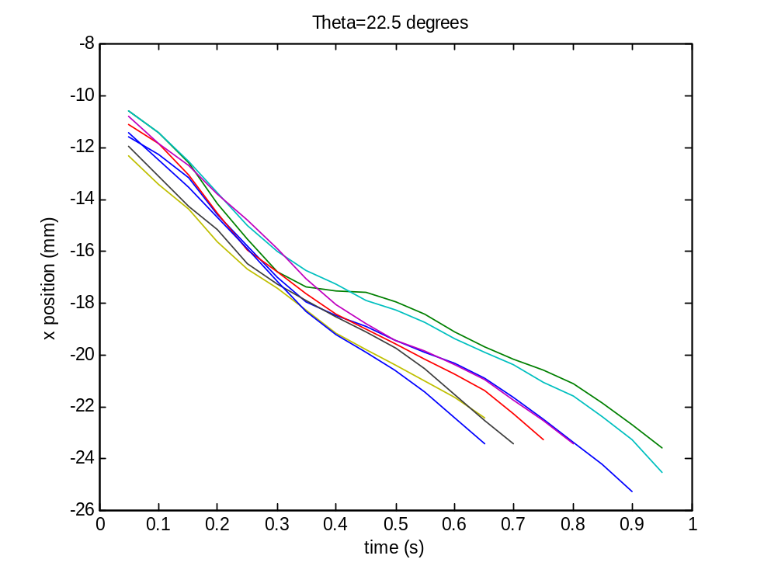
Figure 32: X position vs. time

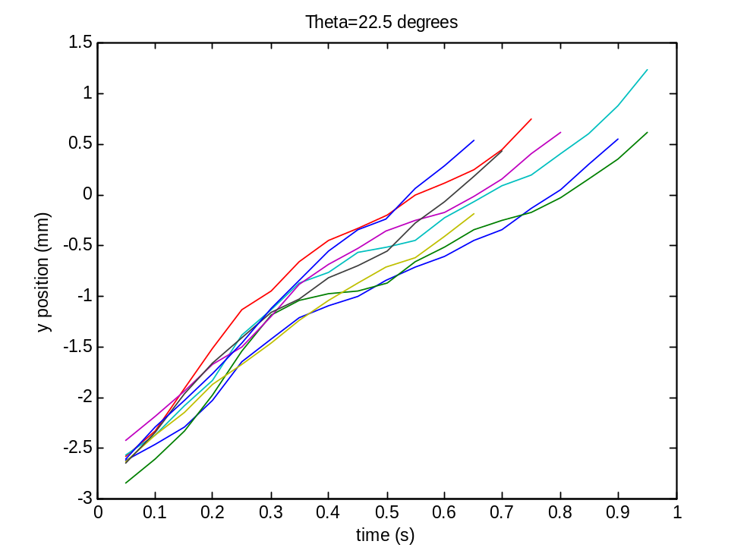
Figure 33: Y position vs. time
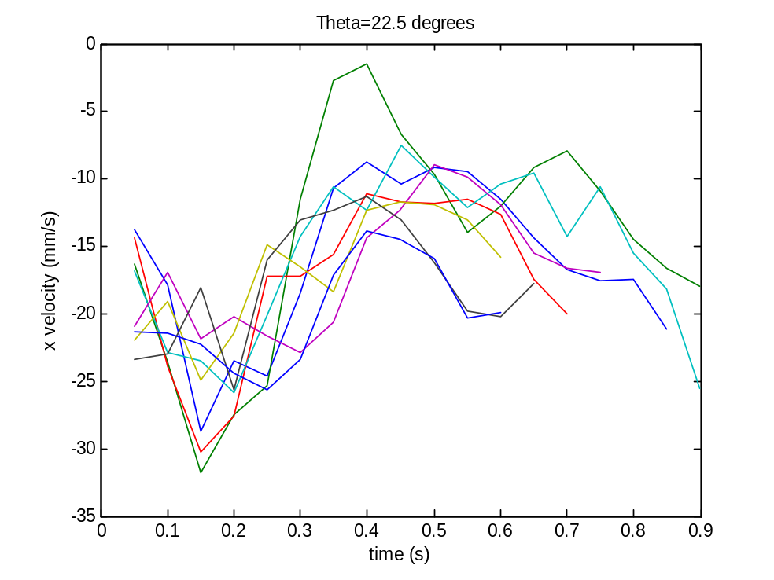
Figure 34: X velocity vs. time

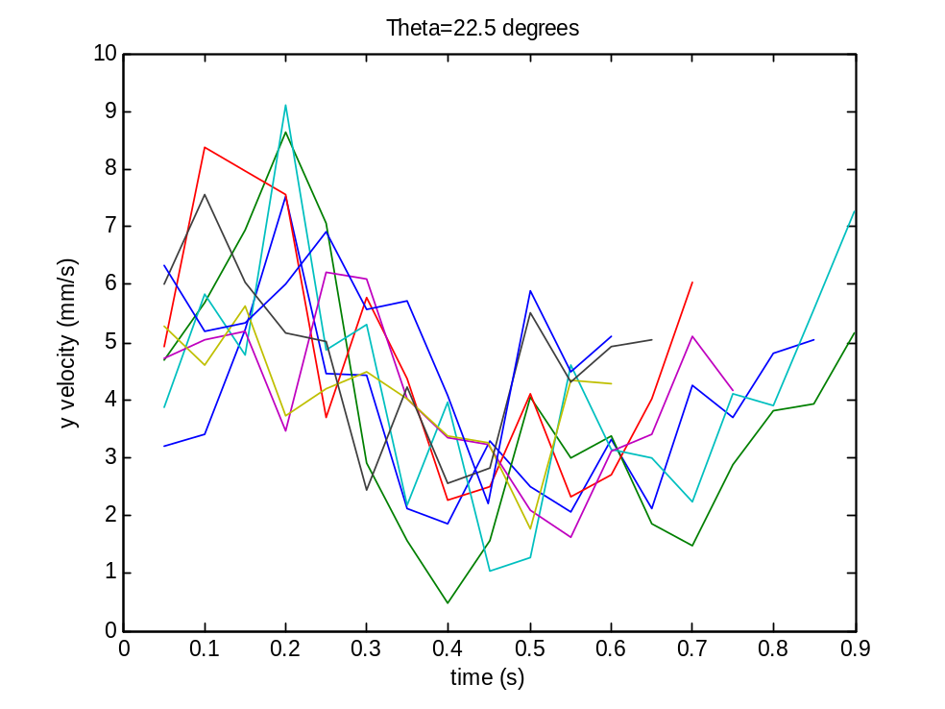
Figure 35: Y velocity vs. time

Table 4 shows a summary of velocity angle and magnitude for all values of θ tested.

Table 4
Shaking Angle (deg) | Part Velocity Angle (deg) | Angle Std | Angle Difference (deg) | Velocity Magnitude (mm/s) | Velocity Std
0 | 1.7 | 0.19 | 1.7 | 20.3 | 5.58
11.25 | 14.6 | 0.74 | 3.35 | 17.4 | 5.56
22.5 | 26.8 | 2.3 | 4.3 | 16.7 | 5.98
33.75 | 41.4 | 1.02 | 7.65 | 22.9 | 7.54
45 | 53.6 | 3.91 | 8.6 | 20.8 | 6.53
56.25 | 67.7 | 1.35 | 11.45 | 19.2 | 3.8
67.5 | 75.2 | 1.23 | 7.7 | 14.5 | 2.54
78.75 | 79.5 | 0.96 | 0.75 | 10 | 3.33
90 | 79.5 | 3.11 | -10.5 | 3.5 | 3.06

Figure 37 shows side by side plots of velocity and magnitude vs. shaking angle, including error bars.

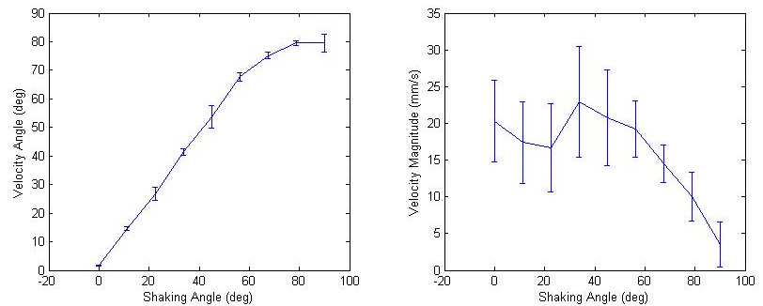
Figure 36: Velocity angle and magnitude vs. shaking angle

Figure 38 shows a plot of the difference between shaking angle and part velocity angle.

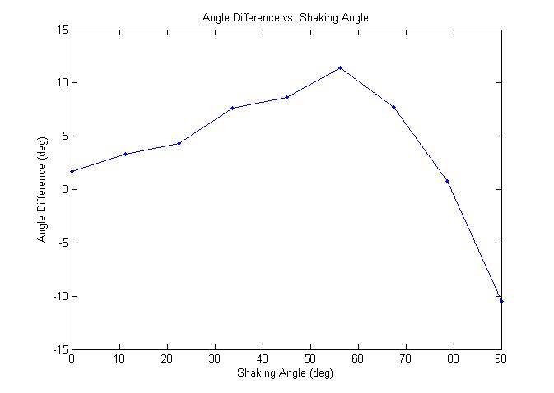
Figure 37: Angle difference vs. shaking angle

For shaking angles between 0° and 78.75°, the part velocity angle was greater than the shaking angle. As expected, the velocity magnitude decreased with increasing θ, as the component of motion along the bias of the plate decreased. The nonzero velocity at θ=90° is peculiar, as there should be no component of velocity along the plate bias. It is possible that this was due to the 3° misalignment between the textured plate axes and the PPOD axes, discussed in section 2.6.

3.4. Conclusion

Hirai’s experiments examining the motion of micro parts on a vibrating saw tooth plate have been replicated, and then generalized to include out of plane vibrations, using the 6 degree of freedom PPOD as a vibratory device. The effect of using in plane vibrations with an angular offset was also explored. With more research, it seems plausible that the bias of the textured plate could be modeled by an anisotropic friction coefficient. These experiments were in part limited by the small size of the textured plate. Therefore, next steps would include obtaining a larger plate, and analyzing part motion under more complicated out of plane vibratory motions. Using a biased plate with in plane vibrations was shown to produce effects similar to that of a trans field in one direction. Exploring other motions with the plate bias may lead to effects that cannot be produced by plate vibrations alone. Both results could prove very useful in a number of different applications.

References

(1) Mitani, Sugano, and Hirai, “Microparts Feeding by a Saw-Tooth Surface,” Trans. Mechatronics, Vol 11, No 6. 2006.

